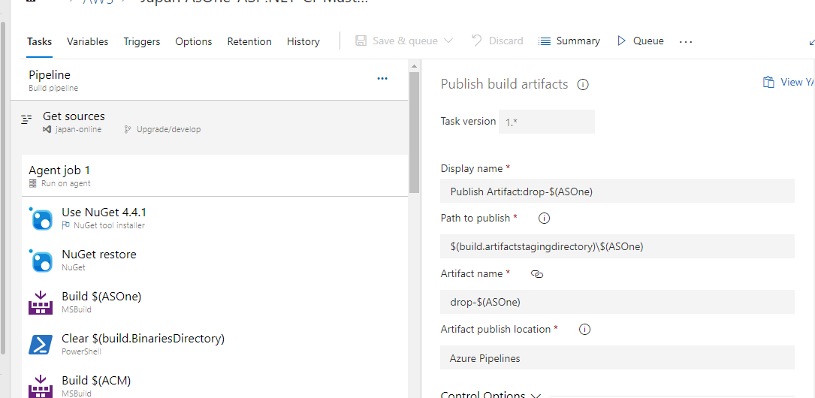

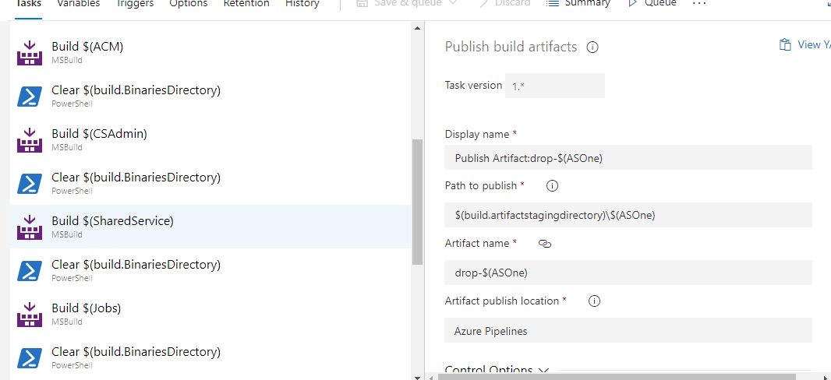

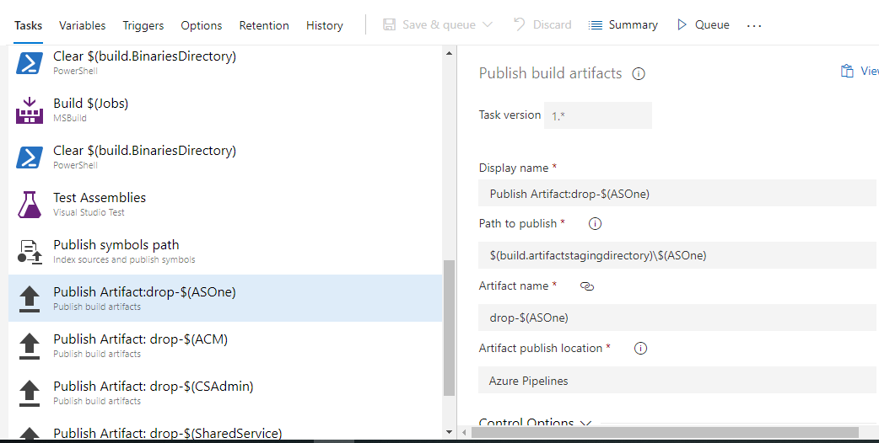

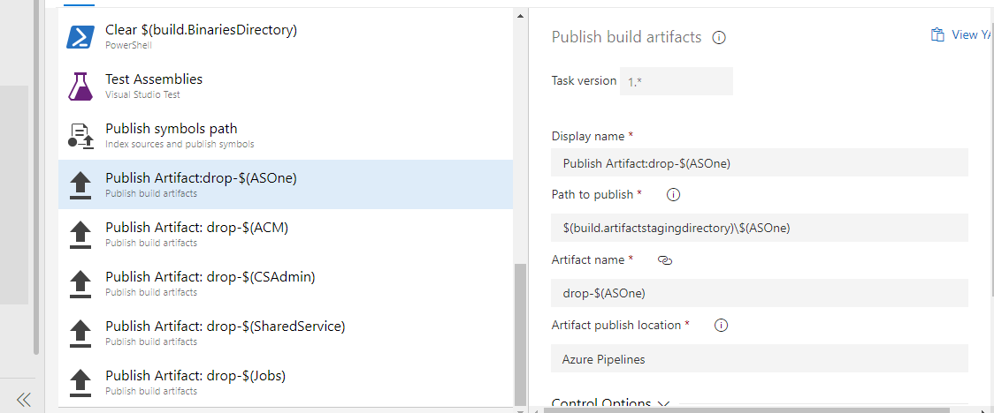

配置

1

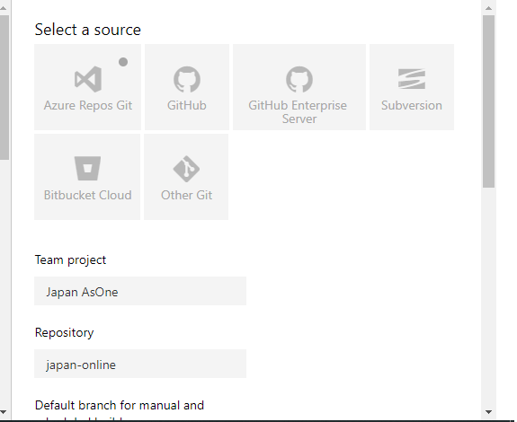

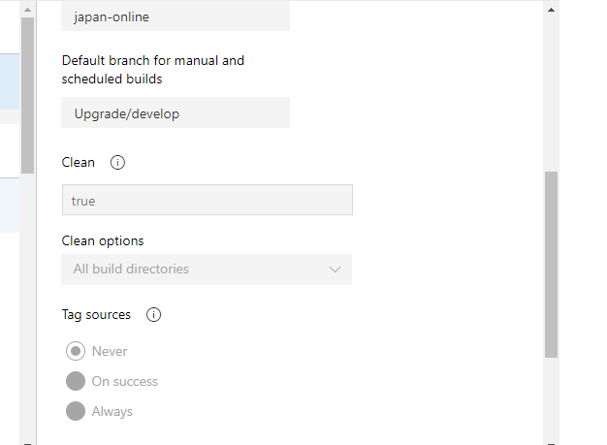

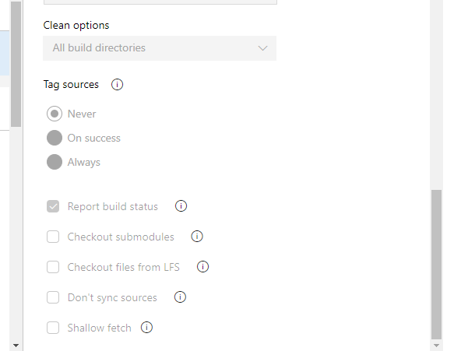

2

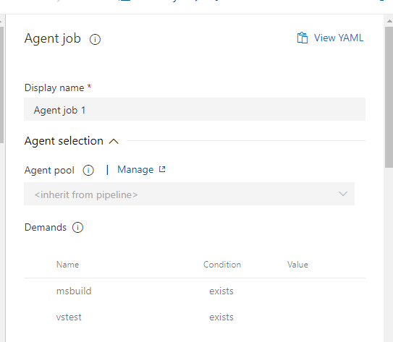

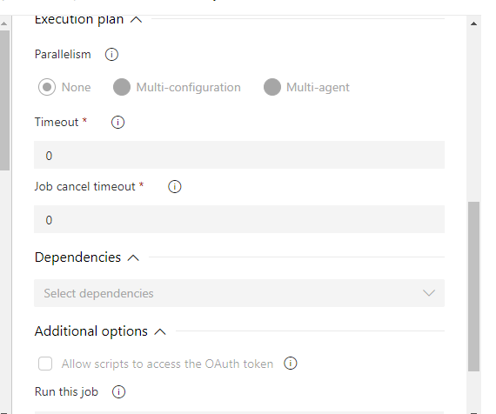

3

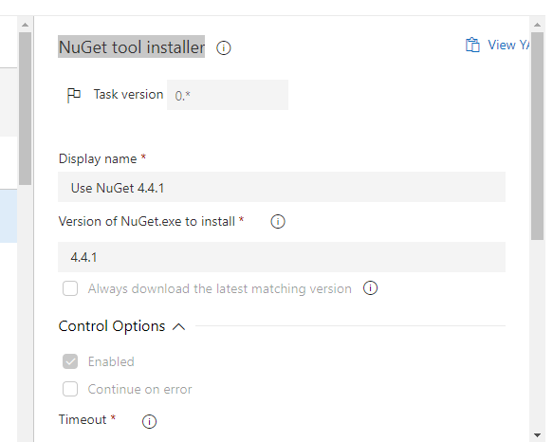

4

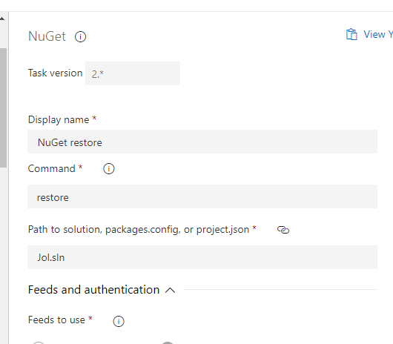

5

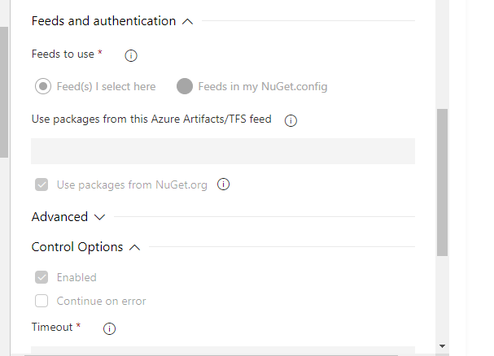

6

#Your build pipeline references the ‘BuildPlatform’ variable, which you’ve selected to be settable at queue time. Create or edit the build pipeline for this YAML file, define the variable on the Variables tab, and then select the option to make it settable at queue time. See https://go.microsoft.com/fwlink/?linkid=865971

#Your build pipeline references the ‘BuildConfiguration’ variable, which you’ve selected to be settable at queue time. Create or edit the build pipeline for this YAML file, define the variable on the Variables tab, and then select the option to make it settable at queue time. See https://go.microsoft.com/fwlink/?linkid=865971

#Your build pipeline references an undefined variable named ‘ASOne’. Create or edit the build pipeline for this YAML file, define the variable on the Variables tab. See https://go.microsoft.com/fwlink/?linkid=865972

#Your build pipeline references an undefined variable named ‘PublishDir’. Create or edit the build pipeline for this YAML file, define the variable on the Variables tab. See https://go.microsoft.com/fwlink/?linkid=865972

#Your build pipeline references an undefined variable named ‘ASOne’. Create or edit the build pipeline for this YAML file, define the variable on the Variables tab. See https://go.microsoft.com/fwlink/?linkid=865972

steps:

- task: MSBuild@1

displayName: 'Build $(ASOne)'

inputs:

solution: Jol4x/Jol4x.csproj

msbuildArchitecture: x64

platform: '$(BuildPlatform)'

configuration: '$(BuildConfiguration)'

msbuildArguments: '/p:DeployOnBuild=true /p:WebPublishMethod=Package /p:PackageAsSingleFile=true /p:SkipInvalidConfigurations=true /p:PackageLocation="$(build.artifactstagingdirectory)\\$(ASOne)\\" /p:OutputPath="$(build.BinariesDirectory)" /p:CombinateFrontCodes=Yes /p:PathOfFrontCodes="$(PublishDir)\$(ASOne)"'

clean: true

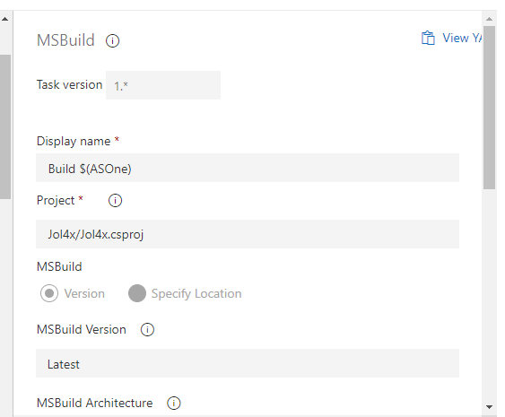

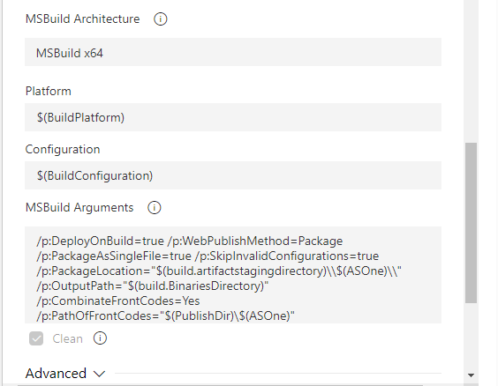

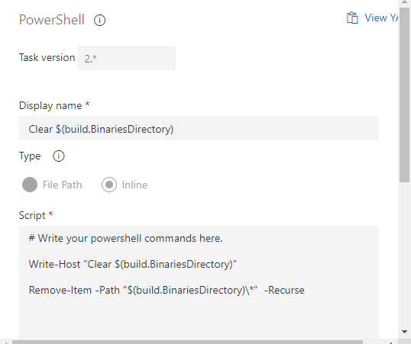

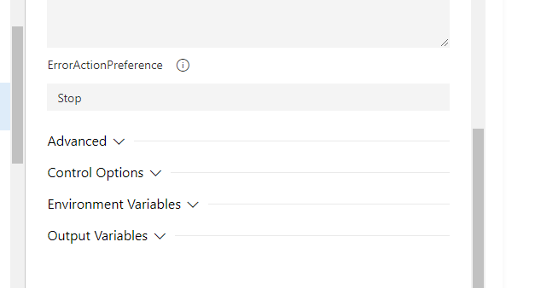

Build $(SharedService)

#Your build pipeline references the ‘BuildPlatform’ variable, which you’ve selected to be settable at queue time. Create or edit the build pipeline for this YAML file, define the variable on the Variables tab, and then select the option to make it settable at queue time. See https://go.microsoft.com/fwlink/?linkid=865971

#Your build pipeline references the ‘BuildConfiguration’ variable, which you’ve selected to be settable at queue time. Create or edit the build pipeline for this YAML file, define the variable on the Variables tab, and then select the option to make it settable at queue time. See https://go.microsoft.com/fwlink/?linkid=865971

#Your build pipeline references an undefined variable named ‘SharedService’. Create or edit the build pipeline for this YAML file, define the variable on the Variables tab. See https://go.microsoft.com/fwlink/?linkid=865972

steps:

- task: MSBuild@1

displayName: 'Build $(SharedService)'

inputs:

solution: aprestservices/aprestservices.csproj

msbuildArchitecture: x64

platform: '$(BuildPlatform)'

configuration: '$(BuildConfiguration)'

msbuildArguments: '/p:DeployOnBuild=true /p:WebPublishMethod=Package /p:PackageAsSingleFile=true /p:SkipInvalidConfigurations=true /p:PackageLocation="$(build.artifactstagingdirectory)\\$(SharedService)\\" /p:OutputPath="$(build.BinariesDirectory)"'

clean: true

Build $(Jobs)

#Your build pipeline references the ‘BuildPlatform’ variable, which you’ve selected to be settable at queue time. Create or edit the build pipeline for this YAML file, define the variable on the Variables tab, and then select the option to make it settable at queue time. See https://go.microsoft.com/fwlink/?linkid=865971

#Your build pipeline references the ‘BuildConfiguration’ variable, which you’ve selected to be settable at queue time. Create or edit the build pipeline for this YAML file, define the variable on the Variables tab, and then select the option to make it settable at queue time. See https://go.microsoft.com/fwlink/?linkid=865971

#Your build pipeline references an undefined variable named ‘Jobs’. Create or edit the build pipeline for this YAML file, define the variable on the Variables tab. See https://go.microsoft.com/fwlink/?linkid=865972

steps:

- task: MSBuild@1

displayName: 'Build $(Jobs)'

inputs:

solution: JobsWeb/JobsWeb.csproj

msbuildArchitecture: x64

platform: '$(BuildPlatform)'

configuration: '$(BuildConfiguration)'

msbuildArguments: '/p:DeployOnBuild=true /p:WebPublishMethod=Package /p:PackageAsSingleFile=true /p:SkipInvalidConfigurations=true /p:PackageLocation="$(build.artifactstagingdirectory)\\$(Jobs)\\" /p:OutputPath="$(build.BinariesDirectory)"'

clean: true

Clear $(build.BinariesDirectory)"

steps:

- powershell: |

# Write your powershell commands here.

Write-Host "Clear $(build.BinariesDirectory)"

Remove-Item -Path "$(build.BinariesDirectory)\*" -Recurse

displayName: 'Clear $(build.BinariesDirectory)'

Publish symbols path

steps:

- task: PublishSymbols@2

displayName: 'Publish symbols path'

inputs:

SearchPattern: '**\bin\**\*.pdb'

PublishSymbols: false

continueOnError: true

Publish Artifact:drop-$(ASOne)

#Your build pipeline references an undefined variable named ‘ASOne’. Create or edit the build pipeline for this YAML file, define the variable on the Variables tab. See https://go.microsoft.com/fwlink/?linkid=865972

#Your build pipeline references an undefined variable named ‘Parameters.ArtifactName’. Create or edit the build pipeline for this YAML file, define the variable on the Variables tab. See https://go.microsoft.com/fwlink/?linkid=865972

steps:

- task: PublishBuildArtifacts@1

displayName: 'Publish Artifact:drop-$(ASOne)'

inputs:

PathtoPublish: '$(build.artifactstagingdirectory)\$(ASOne)'

ArtifactName: '$(Parameters.ArtifactName)'

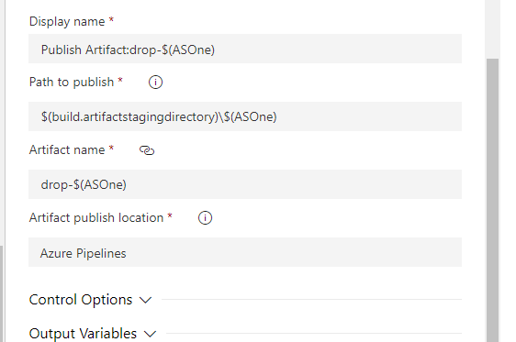

Publish Artifact: drop-$(SharedService)

#Your build pipeline references an undefined variable named ‘SharedService’. Create or edit the build pipeline for this YAML file, define the variable on the Variables tab. See https://go.microsoft.com/fwlink/?linkid=865972

#Your build pipeline references an undefined variable named ‘SharedService’. Create or edit the build pipeline for this YAML file, define the variable on the Variables tab. See https://go.microsoft.com/fwlink/?linkid=865972

steps:

- task: PublishBuildArtifacts@1

displayName: 'Publish Artifact: drop-$(SharedService)'

inputs:

PathtoPublish: '$(Build.ArtifactStagingDirectory)\$(SharedService)'

ArtifactName: 'drop-$(SharedService)'

Publish Artifact: drop-$(Jobs)

#Your build pipeline references an undefined variable named ‘Jobs’. Create or edit the build pipeline for this YAML file, define the variable on the Variables tab. See https://go.microsoft.com/fwlink/?linkid=865972

#Your build pipeline references an undefined variable named ‘Jobs’. Create or edit the build pipeline for this YAML file, define the variable on the Variables tab. See https://go.microsoft.com/fwlink/?linkid=865972

steps:

- task: PublishBuildArtifacts@1

displayName: 'Publish Artifact: drop-$(Jobs)'

inputs:

PathtoPublish: '$(Build.ArtifactStagingDirectory)\$(Jobs)'

ArtifactName: 'drop-$(Jobs)'

